**COMPREHENSIVE AUTOMATED DOCUMENT VERIFICATION SYSTEM FOR OFFICIAL DOCUMENTATION**

## A PROJECT REPORT

***Submitted by,***

|  |  |
| --- | --- |
| **Sahana H** | **20211CSG0017** |
| **Sangeetha S K** | **20211CSG0003** |
| **Amrutheshwari V S** | **20211CSG0037** |
| **Sunitha Gahana** | **20211CSG0038** |

### *Under the guidance of,*

**MS. RADHIKA SREEDHARAN**

***in partial fulfillment for the award of the degree of***

**BACHELOR OF TECHNOLOGY**

**IN**

**COMPUTER SCIENCE AND TECHNOLOGY**

**At**



**PRESIDENCY UNIVERSITY**

**BENGALURU**

**MAY 2025**

**PRESIDENCY UNIVERSITY**

**PRESIDENCY SCHOOL OF COMPUTER SCIENCE ENGINEERING**

**CERTIFICATE**

This is to certify that the Project report **“Comprehensive Automated Document Verification System for Official Documentation”** being submitted by “Sahana H, Sangeetha S K, Amrutheshwari V S, Sunitha Gahana” bearing roll numbers “20211CSG0017, 20211CSG0003, 20211CSG0037, 20211CSG0038” in partial fulfillment of the requirement for the award of the degree of Bachelor of Technology in Computer Science and Technology is a bonafide work carried out under my supervision.

|  |  |
| --- | --- |
| **MS. RADHIKA SREEDHARAN**  Assistant Professor  Presidency School of CSE  Presidency University | **DR. SAIRA BANU ATHAM**  Professor & HoD  Presidency School of CSE  Presidency University |

|  |  |
| --- | --- |
| **Dr. MYDHILI NAIR**  Associate Dean  Presidency School of CSE  Presidency University | **Dr. SAMEERUDDIN KHAN**  Pro-Vc School of Engineering Dean – Presidency School of CSE  Presidency University |

**PRESIDENCY UNIVERSITY**

**PRESIDENCY SCHOOL OF COMPUTER SCIENCE ENGINEERING**

**DECLARATION**

We hereby declare that the work, which is being presented in the project report entitled **Comprehensive Automated Document Verification System for Official Documentation** in partial fulfillment for the award of Degree of **Bachelor of Technology** in **Computer Science and Engineering**, is a record of our own investigations carried under the guidance of **Ms. Radhika Sreedharan,** Associate Professor, **Presidency** **School of Computer Science Engineering, Presidency University, Bengaluru.**

We have not submitted the matter presented in this report anywhere for the award of any other Degree.

|  |  |  |
| --- | --- | --- |
| **Name** | **Roll No** | **Signature** |
| Sahana H | 20211CSG0017 |  |
| Sangeetha S K | 20211CSG0003 |  |
| Amrutheshwari V S | 20211CSG0037 |  |
| Sunitha Gahana | 20211CSG0038 |  |

**ABSTRACT**

In an era of increasing digitization, the authenticity and validity of official documents play a vital role across various sectors such as education, healthcare, banking, and government services. Traditional manual verification methods are time-consuming, inconsistent, and susceptible to human error. To overcome these limitations, this project proposes a **Comprehensive Automated Document Verification System for Official Documentation**, which offers a reliable, scalable, and efficient solution for verifying identity-related documents like Aadhaar cards and PAN cards.

The system is designed as a web-based application comprising a frontend interface and a robust backend engine. The **frontend**, developed using HTML, CSS, and JavaScript, enables users to upload documents through a clean and intuitive interface. The **backend**, implemented in Python, processes the uploaded documents, extracts essential information, and verifies them using predefined logic and mock validation mechanisms. This modular approach ensures a clear separation of concerns and enhances maintainability.

The primary goal of this system is to reduce the manual workload involved in document verification, enhance the accuracy of the process, and ensure faster turn-around time in institutional and organizational workflows. The solution also emphasizes data security and privacy, offering a secure environment for handling sensitive information. Furthermore, the architecture is designed to be extensible, enabling future integration with national databases or third-party APIs for real-time verification.

This automated system represents a significant step towards modernizing document authentication processes and delivering a streamlined experience for both users and organizations.

**ACKNOWLEDGEMENT**

First of all, we indebted to the **GOD ALMIGHTY** for giving me an opportunity to excel in our efforts to complete this project on time.

We express our sincere thanks to our respected dean **Dr. Md. Sameeruddin Khan**, Pro-VC, and Dean, Presidency School of Computer Science and Engineering, Presidency University for getting us permission to undergo the project.

We express our heartfelt gratitude to our beloved Associate Deans **Dr. Shakkeera L and Dr. Mydhili Nair,** Presidency School of Computer Science Engineering, Presidency University, and **Dr. Saira Banu**, Head of the Department, Presidency School of Computer Science Engineering, Presidency University, for rendering timely help in completing this project successfully.

We are greatly indebted to our guide **Ms. Radhika Sreedharan,** Associate Professor and Reviewer **Dr. Madhusudhan M V**, Associate Professor, Presidency School of Computer Science Engineering, Presidency University for her inspirational guidance, and valuable suggestions and for providing us a chance to express our technical capabilities in every respect for the completion of the project work.

We would like to convey our gratitude and heartfelt thanks to the PIP4004 Capstone Project Coordinators **Dr. Sampath A K and Mr. Md Zia Ur Rahman,** department Project Coordinators **Dr. Manjula H M** and Git hub coordinator **Mr. Muthuraj.**

We thank our family and friends for the strong support and inspiration they have provided us in bringing out this project.

|  |
| --- |
| **Sahana H**  **Sangeetha S K**  **Amrutheshwari V S**  **Sunitha Gahana** |

**LIST OF TABLES**

|  |  |  |  |
| --- | --- | --- | --- |
| **Sl. No.** | **Table Name** | **Table Caption** | **Page No.** |
| 1. | Table 7.1 | Gantt Chart | 16 |

**LIST OF FIGURES**

|  |  |  |  |
| --- | --- | --- | --- |
| **Sl. No.** | **Figure Name** | **Caption** | **Page No.** |
| 1. | Fig 4.1 | Workflow of Document Verification System on Blockchain for KYC Compliance | 8 |
| 2. | Fig 5.1 | Structure of Aadhaar Card used for Identity Verification | 11 |
| 3. | Fig 6.1 | Process Flow Aadhaar AI-OCR & Computer Vision Tool | 15 |
| 4. | Screenshot 1 | Home Page | 25 |
| 5. | Screenshot 2 | Home Page (1) | 25 |
| 6. | Screenshot 3 | Output | 26 |
| 7. | Screenshot 4 | SDG’s | 27 |

**TABLE OF CONTENTS**

|  |  |  |
| --- | --- | --- |
| **CHAPTER NO.** | **TITLE** | **PAGE NO.** |
|  | **CERTIFICATE**  **DECLARATION**  **ABSTRACT**  **ACKNOWLEDGMENT**  **List of Tables**  **List of Figures** | **ii**  **ⅲ**  **ⅳ**  **ⅴ**  **ⅵ**  **ⅶ** |
| **1.** | **INTRODUCTION** | **1** |
|  | 1.1 Background of the project | 1 |
|  | 1.2 Problem Statement | 1 |
|  | 1.3 Objective of the Project | 1 |
|  | 1.4 Scope of the Project | 2 |
|  | 1.5 Methodology | 2 |
| **2.** | **LITERATURE SURVEY** | **3** |
|  | 2.1 Review of Related Works | 3 |
| **3.** | **RESEARCH GAPS OF EXISTING METHODS** | **6** |
|  | 3.1 Lack of Robust Forgery Detection | 6 |
|  | 3.2 Limited Dataset Diversity | 6 |
|  | 3.3 Poor Explainability of AI Decisions | 6 |
|  | 3.4 One-size-fits-all Approaches | 7 |
|  | 3.5 Lack of End-to-End Integration | 7 |
|  | 3.6 Absence of Real-time Feedback and Usability | 7 |
| **4.** | **PROPOSED METHODOLOGY** | **9** |
|  | 4.1 System Architecture Overview | 9 |
|  | 4.2 Data Collection and Preprocessing | 10 |
|  | 4.3 OCR for Text Extraction | 10 |
|  | 4.4 Deep Learning for Forgery Detection | 10 |
|  | 4.5 Field Validation and Logic Checks | 10 |
|  | 4.6 Frontend Integration | 10 |
|  | 4.7 System Flow Diagram | 11 |
|  | 4.8 Summary | 11 |
| **5.** | **OBJECTIVES** | **12** |
|  | 5.1 To Develop an End-to-End Document Verification Platform | 12 |
|  | 5.2 To Integrate OCR for Accurate Text Extraction | 12 |
|  | 5.3 To Implement AI-Based Forgery Detection | 12 |
| ‘ | 5.4 To Perform Field-Level Validation and Consistency Checks | 12 |
|  | 5.5 To Build a User-Friendly Interface | 12 |
|  | 5.6 To Ensure Scalability and Modularity | 12 |
|  | 5.7 To Enable Real-Time Feedback | 12 |
| **6.** | **SYSTEM DESIGN & IMPLEMENTATION** | **13** |
|  | 6.1 Overall Architecture | 13 |
|  | 6.2 Frontend Design | 13 |
|  | 6.3 Backend Workflow | 13 |
|  | 6.4 OCR Integration | 14 |
|  | 6.5 Forgery Detection Using Deep Learning | 14 |
|  | 6.6 Validation Logic Layer | 14 |
|  | 6.7 Error Handling and Feedback | 14 |
|  | 6.8 File Structure & Folder Setup | 15 |
|  | 6.9 Deployment and Testing | 15 |
| **7.** | **TIMELINE** | **16** |
| **8.** | **OUTCOMES** | **17** |
|  | 8.1 Successful Implementation of Document Upload and OCR Extraction | 17 |
|  | 8.2 Real-Time Forgery Detection using CNN Model | 17 |
|  | 8.3 Field Validation and Format Enforcement | 17 |
|  | 8.4 Seamless User Interface and Experience | 18 |
|  | 8.5 Error Handling and Fault Tolerance | 18 |
|  | 8.6 Modular and Scalable Architecture | 18 |
|  | 8.7 Readiness for Real-World Use | 18 |
| **9.** | **RESULTS AND DISCUSSIONS** | **19** |
|  | 9.1 OCR Accuracy and Field Extraction | 19 |
|  | 9.2 Forgery Detection Model Performance | 19 |
|  | 9.3 Execution Time and Responsiveness | 19 |
|  | 9.4 Comparison with Existing Systems | 20 |
|  | 9.5 User Testing and Interface Feedback | 20 |
|  | 9.6 Limitations Observed | 20 |
|  | 9.7 Summary of Results | 20 |
| **10.** | **CONCLUSION** | **21** |
|  | 10.1 Future Enhancements | 21 |
| **11.** | **REFERENCES** | **22** |
| **12.** | **APPENDIX-A, PSUEDO CODE** | **23** |
| **13.** | **APPENDIX-B, SCREENSHOTS** | **25** |
| **14.** | **APPENDIX-C, SDG’s** | **27** |

**CHAPTER-1**

**INTRODUCTION**

In today's digital world, verifying the authenticity of identity documents is vital for secure access, financial transactions, and online services. Manual verification methods are time-consuming, prone to human error, and vulnerable to document forgery. To address these issues, this project proposes an AI-based system that automates the verification of Aadhaar, PAN cards, and similar documents. The system integrates OCR and deep learning to extract, analyze, and validate document data. It aims to deliver a scalable, user-friendly solution to streamline identity verification processes.

**1.1 Background of the Project**

Document verification is an essential component of identity management and regulatory compliance. Traditionally, this has been a manual process involving visual inspection and human judgment, which introduces subjectivity and delays. With the emergence of artificial intelligence, especially deep learning and computer vision, there is a shift towards automating document verification. Technologies like OCR allow machines to read printed or handwritten text, while deep learning can identify patterns and anomalies. Together, they offer a promising path to efficient and accurate document authentication systems [1], [4].

**1.2 Problem Statement**

Manual verification of identity documents is inefficient, especially as the demand for digital onboarding and online services increases. Errors due to fatigue, oversight, or document tampering can lead to serious security and operational issues. Identity fraud—through forged Aadhaar or PAN cards—poses a threat to institutions and individuals alike. Current automated systems may lack accuracy, adaptability, or scalability. Thus, a robust AI-powered system is needed to verify documents reliably, detect forgeries, and reduce human dependency [2], [3].

**1.3 Objective of the Project**

This project aims to build a document verification system that:

* Uses OCR to extract text from Aadhaar, PAN, and similar documents.
* Applies deep learning to detect forgeries and validate data.
* Provides a simple frontend for document upload and status display.
* Flags anomalies or mismatches based on layout, content, or structure.
* Ensures accuracy, security, and speed in the verification process.

By integrating AI components, the system should minimize false positives and streamline verification workflows.

**1.4 Scope of the Project**

The project focuses on verifying Indian identity documents—Aadhaar and PAN cards—in a semi-real-world simulation. The backend is designed with modularity to allow expansion to other document types like passports, driving licenses, etc. The frontend interface enables users to upload images or PDFs, while the backend processes the documents using OCR and AI models. The scope includes document classification, text extraction, field validation, and fraud detection. Integration with databases is assumed but not developed in this prototype. The final system should be adaptable across fintech, ed-tech, and e-governance platforms [5], [8].

**1.5 Methodology**

The proposed system will be developed using the following methodology:

* Collect a sample dataset of real and tampered Aadhaar and PAN cards.
* Preprocess images (resizing, binarization, noise removal) to enhance OCR accuracy.
* Use Tesseract or other OCR engines for extracting key data fields like Name, DOB, ID number.
* Train deep learning models (CNNs) to detect forgeries based on visual artifacts and layout features [2], [6].
* Validate extracted data using basic rules (e.g., Aadhaar has 12 digits, DOB format).
* Design a frontend using HTML/CSS/JS to allow users to upload documents and receive verification results.

The project follows an iterative development model with continuous testing and improvement.

**CHAPTER-2**

**LITERATURE SURVEY**

The primary focus of this literature survey is to explore existing technologies and methodologies in keyword extraction, academic content management, and secure data access within digital libraries. It highlights the limitations of current systems and suggests potential solutions for creating a more efficient platform for accessing research papers. Key areas of investigation include keyword extraction techniques, academic search system optimization, secure access and content management, and user interface design to enhance user experience.

**2.1 Review of Related Works:**

**Nedoshytko and Patriak [1]** delve into the development and deployment of a three-tier architecture model, incorporating the widely used Model-View-Controller (MVC) design pattern to streamline electronic document management systems in business environments. The three-tier model, which segments the system into the presentation, logic, and data layers, provides a robust foundation for building scalable and modular applications. By adopting the MVC approach, the system further separates the internal representations of information from how it is presented and interacted with by the user. This structural design aids in the independent development and maintenance of each component, facilitating easier updates and improved code reusability. The authors emphasize the importance of clear role separation, where the Model handles business logic and data, the View manages the user interface, and the Controller interprets user inputs. A user interface prototype was created using Figma to visually design and test user interaction workflows, allowing for iterative refinement based on user feedback and usability principles.

The results of the study indicated that such an automated, MVC-based architecture significantly enhances the efficiency of routine document processing tasks, thereby increasing overall productivity in office operations. By minimizing manual intervention and automating repetitive tasks, the system allows personnel to focus on higher-value activities. Despite these benefits, the researchers acknowledged several critical challenges that must be addressed for successful implementation. Among these are concerns related to user adoption, especially in organizations where employees may resist changes to established workflows. Moreover, integrating the new system with legacy infrastructure and maintaining high standards of data security and confidentiality are noted as ongoing obstacles. The study concludes that while the MVC-based approach presents a promising direction for electronic document management, future work must focus on seamless integration, user training, and enhanced security frameworks to ensure long-term viability and organizational acceptance.

**Vallayil et al. [2]** explore a critical aspect of Automated Fact Verification (AFV) systems—explainability, particularly in the context of deep learning-based approaches. The study investigates how current AFV systems, while often achieving high accuracy, tend to function as black-box models, offering limited insight into their reasoning processes. This lack of transparency poses significant challenges, especially in domains where trust, accountability, and verification of outputs are essential. The authors conduct a thorough review of AFV methodologies, focusing on the extent to which these systems provide logical and comprehensible explanations to human users. By analyzing a variety of existing models and benchmark datasets, the study identifies a prevailing trade-off between performance and interpretability, where highly accurate systems frequently sacrifice the clarity of their internal decision-making processes.

Furthermore, the authors advocate for the development and use of Explanation-Learning-Friendly (ELF) datasets that are specifically designed to support models in generating interpretable outputs without compromising accuracy. The study emphasizes that the lack of such datasets hinders progress in producing transparent and explainable AFV models. Additionally, Vallayil et al. highlight inconsistencies in the application of explainability frameworks across different research efforts, which limits the ability to make meaningful comparisons between models. The study concludes that although some progress has been made, current AFV systems fall short of providing user-friendly, logically coherent justifications for their conclusions. As a result, there is a pressing need for more standardized, explainability-oriented design principles, both in model architecture and dataset creation, to ensure these systems can be trusted and understood by end users.

**Somsuk [3]** introduces an innovative approach to digital signing and verification by leveraging RSA cryptography in conjunction with the Chinese Remainder Theorem (CRT), aiming to enhance computational efficiency without compromising security. The primary goal of the study is to optimize the RSA algorithm, which is widely used for secure digital communications, to accelerate the processes involved in digital signature generation and verification. By incorporating CRT—a number-theoretic technique that allows modular arithmetic operations to be computed more efficiently—the proposed method significantly reduces the time complexity of cryptographic operations. This makes the approach particularly attractive for applications involving large volumes of document authentication, where speed and accuracy are critical. The study provides experimental results demonstrating that the optimized algorithm achieves notable improvements in verification time while upholding the core principles of digital integrity and non-repudiation.

In addition to improving speed, the method reduces the number of bits that need to be processed during signature verification, thereby lowering computational overhead. Nevertheless, the approach continues to ensure secure and reliable identity verification, which is crucial for official digital documents such as contracts, certificates, and government records. However, Somsuk also acknowledges limitations within the proposed method. Most notably, the system is tailored specifically for official digital documents and lacks the flexibility required for broader cryptographic applications, such as dynamic key exchanges, real-time communications, or multi-party transactions. The dependence on specific RSA configurations also restricts adaptability to evolving cryptographic standards. Therefore, while the study makes a valuable contribution to the field of efficient document authentication, future research must explore how such optimizations can be extended or generalized to serve more diverse and demanding cryptographic use cases.

**Tsybulnyk et al. [4]** propose an advanced, AI-driven document verification system that integrates Optical Character Recognition (OCR) for accurate text extraction and machine learning (ML) algorithms for robust fraud detection. The system is designed to automate the verification of official documents by analyzing text content and identifying inconsistencies or anomalies that may indicate forgery or manipulation. OCR plays a vital role in digitizing physical documents, allowing the system to parse and interpret various document formats with high precision. Machine learning models are trained on large datasets of verified and fraudulent documents to improve their ability to detect subtle signs of tampering, thereby increasing the reliability of the verification process. Moreover, the architecture incorporates blockchain technology as a foundational element for ensuring the immutability of documents once verified. By recording document hashes on a decentralized ledger, the system guarantees that once a document is stored, it cannot be altered without detection, which greatly enhances trust in the document management lifecycle.

The study underscores the system's effectiveness in minimizing fraud risks while offering a secure and traceable retrieval mechanism. It supports multi-user interactions, enabling various stakeholders—such as institutions, regulators, and users—to participate in the verification process while maintaining transparency and accountability. However, the authors acknowledge several implementation challenges. Chief among these is the high computational cost associated with the concurrent use of AI and blockchain technologies, both of which demand significant processing power and infrastructure. Additionally, ensuring regulatory compliance remains a major hurdle, especially when deploying the system across different jurisdictions with varying legal and data protection standards. The study concludes that while the proposed system demonstrates great promise in enhancing document verification through technological convergence, further work is needed to address scalability, legal interoperability, and cost-efficiency for widespread adoption.

**Sudharshan and Vismaya [5]** explore the use of deep learning techniques for document verification, focusing specifically on the analysis of handwritten signatures as a biometric authentication method. Their research utilizes Recurrent Neural Networks (RNNs), particularly those enhanced with Long Short-Term Memory (LSTM) units, to model the temporal dynamics and unique motion patterns inherent in handwritten signatures. Unlike static image analysis, the RNN-LSTM architecture captures the sequence and flow of pen strokes, which is essential in distinguishing genuine signatures from forgeries. The model is trained on datasets containing both authentic and forged signature samples, allowing it to learn nuanced differences in signing behavior. The authors emphasize that the system is capable of handling a wide range of intra-class variability—such as differences in speed, pressure, and orientation—making it a robust solution for real-world verification scenarios where exact replication is rare.

The study reports high accuracy in identifying fraudulent signatures, particularly in cases where forgeries fail to replicate the subtle dynamics of an individual’s natural signing style. However, the authors also acknowledge several limitations in the system’s practical deployment. Most notably, the RNN-LSTM model exhibits high sensitivity to noise and distortions present in low-quality or misaligned signature samples. Such noise may arise from poor scanning conditions, background interference, or inconsistent positioning of the signature on the document. These factors can significantly degrade model performance, leading to false positives or negatives. As a result, the researchers recommend integrating preprocessing techniques such as image normalization, alignment correction, and noise filtering to improve reliability. While the study demonstrates the promise of deep learning for signature-based document verification, it also highlights the need for robust data preprocessing and adaptive model tuning to ensure consistent performance across diverse document environments.

**Yadav [6]** investigates the automated verification of identity documents by combining deep learning techniques with traditional feature matching methods. The research emphasizes the use of the Scale-Invariant Feature Transform (SIFT) algorithm to extract distinctive, scale- and rotation-invariant features from identity document images. These features capture essential visual elements such as text alignment, logo positioning, and background textures, which are crucial in identifying subtle manipulations or forgeries. Once the key features are extracted, they are fed into a deep learning model designed for image comparison, enabling the system to evaluate the authenticity of the document by comparing it with a database of verified templates. This hybrid approach capitalizes on the precision of handcrafted feature detection offered by SIFT and the pattern recognition strength of deep learning, creating a system that can adapt to a wide range of document types and tampering techniques.

The study reports that integrating both feature-based and deep learning models significantly improves verification accuracy, particularly when detecting fine-grained alterations that may not be apparent through either method alone. This combined methodology proves effective in scenarios where attackers attempt minor yet critical changes, such as altering dates or identification numbers. However, the approach is not without limitations. The system exhibits reduced performance when processing images that are heavily distorted, blurred, or captured under poor lighting conditions—situations that can compromise the clarity and consistency of feature extraction. Such issues lead to an increased rate of false negatives, where authentic documents may be incorrectly flagged as fraudulent. To mitigate this, the study suggests further research into robust preprocessing methods and data augmentation techniques that can improve the model’s tolerance to visual noise and distortions. Overall, the research demonstrates the potential of hybrid verification systems, while acknowledging the need for enhancements in handling low-quality input data.

**Castelblanco, Solano, and Lopez [7]** introduce a comprehensive machine learning-based pipeline designed specifically for verifying identity documents using mobile devices. Recognizing the increasing reliance on smartphones for digital verification, the authors focus on creating a lightweight yet robust system that can process images of identity documents captured through mobile cameras. The proposed system integrates several analysis modules that work in tandem to extract and evaluate key visual features from the input image, such as background textures, fonts, and document layout. A background detection component is employed to assess whether the document adheres to known patterns, which is critical in identifying tampered or synthetic backgrounds. This component alone achieved an impressive 98.4% accuracy, demonstrating the system’s ability to distinguish authentic document features from manipulated ones.

Additionally, the pipeline includes an authenticity classifier that leverages the extracted visual features to predict the legitimacy of the document, achieving a high accuracy rate of 97.7% and an F1-score of 0.974, reflecting strong performance in both precision and recall. The study highlights the practical benefits of deploying such a system on mobile devices, including increased accessibility and faster verification processes. However, while the authors do not delve deeply into the system’s limitations, they acknowledge challenges associated with inconsistent image quality due to varying camera specifications, lighting conditions, and user handling. These factors can affect feature extraction and model performance, potentially leading to misclassification. Furthermore, maintaining high accuracy across different types of identity documents requires extensive training data to account for format variability and regional differences. The study concludes that while the proposed solution is highly promising for mobile document verification, ongoing work is needed to ensure robustness and generalizability in real-world conditions.

**Salge, Shindkar, and Malve [8]** explore the application of Optical Character Recognition (OCR) technology in the domain of document verification, emphasizing its role in converting printed or handwritten text into machine-readable formats. The paper presents OCR as a foundational tool for digitizing physical documents, which is a critical first step in many automated verification systems. Traditional OCR techniques rely on rule-based systems and pattern matching algorithms to extract textual information, making them well-suited for structured documents with consistent formatting. By converting text into a digital, structured form, OCR facilitates faster processing, searching, and validation of document content. The study underscores the increasing demand for reliable document digitization, especially in sectors like finance, government, and healthcare, where bulk document handling is common. The authors highlight that OCR has the potential to significantly streamline document verification workflows, reducing manual effort and enabling seamless integration with downstream systems like databases and machine learning models.

Despite these advantages, the paper also addresses several challenges associated with OCR technology. One of the primary limitations is its difficulty in accurately parsing complex document layouts, such as tables with indistinct borders, multi-column texts, or documents with mixed orientations. Such formats often lead to incorrect text segmentation or loss of structural information, affecting the accuracy of verification tasks. Moreover, OCR systems perform inconsistently when processing low-resolution images, documents captured under poor lighting, or files with noisy backgrounds. The presence of varied fonts, decorative typefaces, and handwritten content further complicates recognition, often resulting in incomplete or erroneous text extraction. The authors note that while modern OCR engines—such as those powered by deep learning—have made strides in handling diverse inputs, further improvements in layout analysis, preprocessing, and language modeling are required to make OCR more reliable for high-stakes document verification scenarios. The study concludes that OCR serves as a critical enabler for automated verification but must be enhanced through hybrid techniques and better training data to overcome its current limitations.

**CHAPTER-3**

**RESEARCH GAPS OF EXISTING METHODS**

Despite the widespread use of digital document verification systems across various domains—such as banking, government services, and online platforms—several gaps still persist in the current methodologies. Most existing solutions are either too rigid, lack customization options, or depend heavily on third-party APIs that are not always transparent or reliable. Additionally, many of these methods focus solely on the validation aspect, without offering a user-friendly, secure, and integrable workflow for document management. In the context of This project, these limitations expose a need for a system that is not only robust in detecting forgeries or inconsistencies but also developer-friendly, lightweight, and easily adaptable to different domains and use cases. The following subsections outline the specific research gaps in more detail, categorized based on technological, operational, and security perspectives.

**3.1 Lack of Open and Customizable Verification Frameworks**

Most document verification systems are either proprietary or heavily dependent on commercial APIs, leaving little to no room for customization or transparency. These black-box systems limit developers from modifying core functionalities or integrating the system into a broader ecosystem. For instance, government-issued APIs for Aadhaar or PAN card validation often involve complex licensing, strict access control, and predefined behavior that cannot be altered. As a result, institutions seeking to implement document verification have to rely on expensive or inflexible third-party services. There is a significant research gap in developing open-source or semi-open platforms that allow developers to tailor document verification to their domain-specific requirements. This project addresses this by providing a completely custom-built backend where verification rules can be controlled, extended, or replaced as needed.

**3.2 Insufficient Handling of Semi-Structured and Unstructured Document Formats**

Existing solutions typically work well with highly structured formats—those with standardized layouts and fields. However, real-world documents, especially identity proofs like Aadhaar and PAN cards, often appear in scanned or photographic formats, which may include orientation issues, lighting inconsistencies, or occlusions. Many existing systems do not adequately handle these semi-structured or unstructured inputs. They often fail to extract accurate information or misclassify document validity due to the lack of robust preprocessing pipelines or adaptable OCR models. Additionally, very few systems support multi-language document processing or template-based matching that adjusts dynamically. This project identifies this shortcoming by incorporating flexible parsing logic and potential future integration with AI-based document classifiers to improve input tolerance and recognition accuracy.

**3.3 Limited Integration Between Authentication and Document Verification Modules**

A critical gap in many existing implementations is the disconnect between user authentication systems and document verification modules. In practice, these systems operate independently—users log in or register, and only afterward are prompted to upload or verify documents, often with separate workflows. This leads to inefficient user experiences and fragmented security models. A seamless integration between user authentication (like token-based or session-based login systems) and document verification is rarely observed in open projects. In contrast, This project’s architecture aims to unify these components within the same platform. The authentication system directly controls access to the document upload and verification interfaces, ensuring a tightly-coupled and secure process. This unified structure addresses the research gap of fragmented security and user workflows.

**3.4 Poor Support for Real-Time Feedback and Error Correction**

Another major limitation in existing document verification tools is their lack of real-time feedback and intelligent error handling. Users are often required to upload documents and wait for backend processing without receiving any instant insights about errors like image clarity, incorrect file formats, or missing fields. This delay not only frustrates users but also increases the chance of system abandonment. Moreover, most current solutions do not leverage intelligent input correction mechanisms, such as suggesting retakes or providing actionable guidance when an issue is detected. This project considers this challenge and proposes future enhancements including real-time front-end validations and error messages based on backend responses. Although still in development, this component addresses the broader research question of how to build a responsive, interactive verification pipeline that minimizes user errors and improves document quality upon submission.

**3.5 Security Vulnerabilities and Absence of End-to-End Encryption**

Document verification systems deal with highly sensitive personal information, yet many existing platforms do not provide sufficient guarantees about how data is stored, transmitted, or accessed. There is a notable absence of end-to-end encryption protocols or zero-trust principles in many free or even paid services. Data is often stored unencrypted or sent over unsecured channels, making it vulnerable to interception, unauthorized access, or misuse. In addition, access control mechanisms are often too basic, relying only on frontend restrictions without any deeper verification of user roles or token expiry management. This project highlights this flaw by incorporating a backend-based authentication model and planning future additions of data hashing and encryption. This research gap is critical to address, especially in an era of rising data breaches and identity theft. Ensuring data security at every stage—from upload to storage and deletion—must become a foundational requirement, not a feature.

**3.6 Inadequate Focus on Modular and Scalable Architecture**

Many existing document verification systems are built in a monolithic fashion, making them difficult to scale, update, or repurpose for new use cases. When features like new document types, language support, or verification algorithms need to be added, these systems often require significant reengineering or even a full redevelopment. This inflexible architecture makes it challenging for institutions or developers to adopt such systems across different sectors or regions. Additionally, many platforms lack clearly defined module boundaries—for example, separating authentication, document parsing, verification logic, and response generation into independent services. This project explicitly recognizes this architectural limitation and addresses it through a modular design, with clear separation of concerns via independent route and service files. This not only allows easier debugging and maintenance but also ensures the system can be extended over time—for instance, adding support for driving licenses, passports, or academic certificates without reworking the core logic. The gap here lies in a broader failure by existing solutions to embrace scalable, microservice-like design principles that modern systems demand.

**3.7 Absence of Explainable Verification Decisions**

A particularly overlooked issue in the current ecosystem is the absence of transparency in how a document is verified or rejected. Many systems provide only a binary response—valid or invalid—without offering users any insight into what fields were examined, what errors were found, or which data mismatched. This lack of explainability creates mistrust in the system, especially when users receive false negatives or are unaware of what to correct. In sectors like finance, healthcare, and education, explainability is critical not just for user trust, but for legal and compliance reasons. This project identifies this issue and opens up a path to provide detailed feedback with each verification result—whether a name mismatch, photo blur, or missing identifier—thereby increasing both system transparency and user confidence. This area still represents a broad research opportunity: developing interpretable document verification frameworks that clearly communicate decision logic to end-users.

**3.8 Lack of Testing Tools and Sandbox Environments**

Another serious gap in existing document verification methods is the lack of developer-focused tools for testing and validation before deployment. Most available platforms do not offer sandbox environments where developers can simulate real-world document uploads, fake errors, or evaluate edge cases like poor image resolution, low-light conditions, or tampered files. As a result, many systems go live with insufficient testing, leading to critical failures in production environments. Moreover, debugging these systems is cumbersome due to a lack of built-in logging, traceability, or mock data support. This project addresses this challenge by being fully local-first and developer-driven—allowing full control over backend logic, synthetic document testing, and error simulation. However, the research and industry still lack comprehensive, open frameworks where developers and testers can experiment, stress-test, and benchmark document verification systems under various conditions. Building these sandbox environments is essential for improving overall robustness, yet very few solutions offer them out of the box.

**3.9 Limited Accessibility and Inclusivity Considerations**

Most existing document verification systems fail to account for accessibility needs such as screen reader compatibility, language localization, or support for differently-abled users. Visual-only UIs, non-intuitive file upload processes, and lack of audio or text guidance make it hard for many users to complete the verification process successfully. Additionally, platforms often support only English or a single regional language, which poses a barrier in multilingual populations like India. There is a clear gap in research regarding accessible, inclusive, and user-friendly document verification tools that serve all demographics. This project, although in its initial version, has been structured in a way that could incorporate accessibility best practices in future iterations—such as adding voice prompts, regional language support, or simplified UI modes for elderly users. This broader gap highlights a lack of human-centered design in many verification tools and a pressing need for inclusivity in system development.

**3.10 Minimal Use of AI for Adaptive Verification and Fraud Detection**

While AI and machine learning have transformed many fields, their integration into document verification systems remains limited. Most tools still rely on static rule-based verification—matching fields exactly, checking for basic layout templates, or verifying string formats. These approaches, though fast, are vulnerable to minor tampering, template alterations, or forged documents that escape basic checks. There is a research gap in leveraging AI to detect subtle signs of forgery, such as manipulated fonts, pixel anomalies, or inconsistent photo placements. Additionally, adaptive systems that learn from document variations over time—such as different Aadhaar formats issued over the years—are largely absent. This project is currently built on traditional logic for reliability and transparency, but the architecture leaves room for integrating AI models for OCR improvement, fraud pattern detection, and anomaly scoring in future versions. This area of smart verification presents one of the most promising yet underexplored frontiers in digital identity validation.

**CHAPTER-4**

**PROPOSED MOTHODOLOGY**

To address the challenges identified in existing systems, this project proposes a modular, AI-powered document verification platform. The methodology combines optical character recognition (OCR), deep learning-based forgery detection, and a user-friendly interface. The goal is to provide an end-to-end system that can accurately verify identity documents such as Aadhaar and PAN cards. Each component is designed to improve reliability, adaptability, and usability in real-world conditions. This chapter outlines the step-by-step strategy for implementation.

**4.1 System Architecture Overview**

The system architecture leverages a blockchain-based document verification model for KYC compliance. The workflow begins when a customer uploads identity documents such as POI (Proof of Identity) and POA (Proof of Address) to the blockchain. These documents are securely stored and made accessible for verification.

A bank retrieves the submitted documents from the blockchain, performs KYC verification, and updates the customer's status as KYC compliant. This verified KYC status is then recorded immutably on the blockchain, enabling a trusted and auditable trail of verification.

The customer can authorize other banks or businesses to access and verify their KYC status directly from the blockchain. This decentralized model eliminates the need for repeated verifications, enhances data security, and streamlines identity authentication across multiple institutions. Each entity accesses only the necessary KYC status, ensuring data privacy and reducing redundancy.

The architecture ensures data integrity through cryptographic hashing and access control mechanisms. It reduces verification delays, minimizes the risk of document forgery, and facilitates interoperability across banking and financial platforms. Additionally, by leveraging blockchain, the system promotes transparency, tamper resistance, and traceability, making it suitable for high-trust environments like finance and governance.

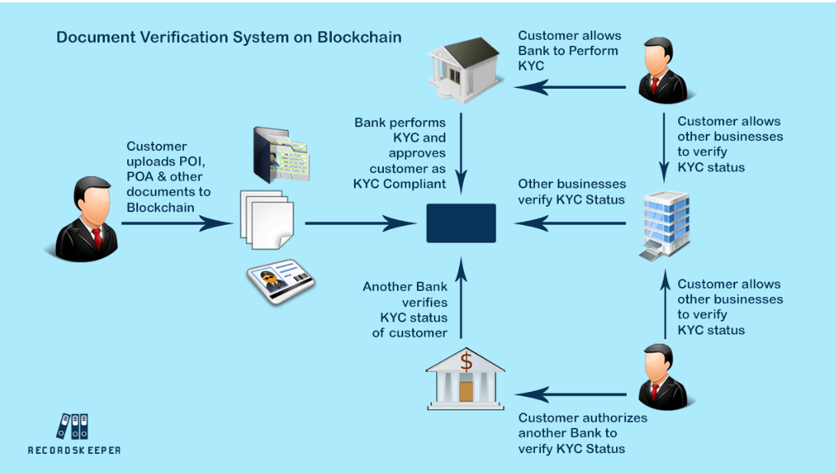

Fig 4.1: Workflow of Document Verification System on Blockchain for KYC Compliance

**4.2 Data Collection and Preprocessing**

The first step of the project involves the systematic collection of Aadhaar and PAN card samples, both genuine and tampered, to create a comprehensive dataset for training and testing the system. These samples are carefully curated to ensure that they reflect a wide range of variations that may occur in real-world scenarios. Data preprocessing plays a critical role in ensuring that the input images are suitable for the next steps of the system. The preprocessing stage includes several key tasks, such as resizing the images to standard dimensions for consistent input, converting the images to grayscale to reduce complexity, and applying binarization techniques to enhance the contrast between text and background. Additionally, noise reduction methods are employed to remove any irrelevant or distracting elements in the images, such as artifacts or distortions caused by scanning or photography. To further strengthen the model's ability to handle real-world conditions, data augmentation techniques, including random rotation and contrast adjustment, are applied to simulate the natural variations found in uploaded documents. These variations could include skewed orientations, changes in lighting, or distortions that occur during document submission. By introducing such variability during training, the system becomes more resilient to the common challenges posed by documents in varying conditions, as emphasized in previous studies [3], [5]. These preprocessing steps ensure that the models are exposed to a wide array of document features, allowing them to generalize effectively across diverse inputs.

**4.3 OCR for Text Extraction**

Optical Character Recognition (OCR) is used as a fundamental step for extracting textual information, such as the name, date of birth, and identification number, from the images of the documents. In this project, Tesseract OCR serves as the base engine, known for its versatility and accuracy in recognizing printed text in images. However, to increase accuracy and efficiency, the OCR engine is customized specifically for this application. The customization includes template-based positional analysis, which helps the system focus on predefined areas of the document where key fields like the identification number or name are typically located. This approach minimizes the impact of irrelevant text and non-essential parts of the document. While OCR is powerful, errors in character recognition are inevitable, especially in low-quality images or in cases of distorted handwriting. To address these challenges, post-processing is applied, including the use of regular expressions to validate the extracted text. For example, the Aadhaar number must be exactly 12 digits, and the PAN number should match the specific format of AAAAA9999A, with letters and numbers in exact positions. These rules ensure that even if OCR recognition is imperfect, the system can filter out implausible values and increase the accuracy of the extracted data. This step not only bridges the gap between raw image data and field-level semantic information but also adds an important layer of error correction, allowing for more reliable document processing [4], [2].

**4.4 Deep Learning for Forgery Detection**

In addition to the textual extraction provided by OCR, the project also incorporates a deep learning-based approach for detecting visually manipulated documents. To identify alterations like copy-paste edges, mismatched fonts, or changes in the background, a Convolutional Neural Network (CNN) model is trained using real and tampered document images. This deep learning model is designed to focus on sensitive fields within the document, such as the identification number and date of birth, where tampering is more likely to occur. The model is trained to recognize small inconsistencies in these fields, which may be difficult for traditional methods to detect, but can be picked up through pixel-level analysis. By focusing on image patches around key areas, the CNN model learns to identify visual cues that differentiate genuine documents from manipulated ones. This advanced detection component fills a significant gap in current systems, where OCR alone often fails to identify tampered images. The ability of deep learning models to detect subtle visual inconsistencies, such as edges left by copy-pasted text or altered backgrounds, is crucial for ensuring the authenticity of identity documents [1], [2], [6]. The combination of OCR for text extraction and deep learning for image manipulation detection creates a more comprehensive and accurate system for verifying documents, especially in cases where text-based analysis might be insufficient.

**4.5 Field Validation and Logic Checks**

Once the textual data is extracted from the document, the next step is to apply a series of validation rules to ensure the consistency and accuracy of the extracted information. This field validation process plays a key role in improving the overall reliability of the system. For example, the birth date extracted from the document is cross-checked to ensure that it falls within an appropriate age range for the person identified on the document. Similarly, the name fields are subjected to checks to ensure they follow conventional alphabetical patterns and do not contain any invalid characters. In cases where the document includes a number or code, such as the Aadhaar or PAN number, checksum validation algorithms are applied to verify the authenticity of the number and ensure that it adheres to expected formats. Even if OCR succeeds in extracting text, these additional logic checks provide an extra layer of security by flagging inconsistent or suspicious patterns that might indicate fraudulent activity. This rule-based validation is especially important in documents like Aadhaar and PAN cards, where the structure and content are highly standardized. By integrating both deep learning for image-level tampering detection and logic-based validation for extracted fields, the system ensures a higher level of verification accuracy and helps to reduce false positives and negatives. This combination of advanced machine learning and traditional validation techniques increases the system's reliability, making it more effective in real-world applications [7].

**4.6 Frontend Integration**

The frontend is built using HTML, CSS, and JavaScript. It includes a simple file upload form, a preview pane for uploaded documents, and a result section that displays extracted data and verification status. The interface also provides error messages and tips for better image capture. This design ensures usability for non-technical users while supporting smooth integration with the backend logic [5], [8].

**4.7 System Flow Diagram**

The flow of the system proceeds as follows:

1. User uploads Aadhaar or PAN card image.
2. The image is sent to the backend for preprocessing and OCR.
3. Extracted data is analyzed and sent to the AI model for forgery detection.
4. Logic checks are applied on the extracted fields.
5. Final status (verified or flagged) is displayed on the frontend.

This methodology ensures real-time feedback and closes the loop between data input and actionable output.

**4.8 System Overview and Future Work**

This chapter outlines the comprehensive methodology of the proposed document verification system, designed to provide an efficient, scalable, and secure solution for verifying identity documents. The system integrates traditional Optical Character Recognition (OCR) with cutting-edge AI-based validation techniques, ensuring that the verification process is both accurate and robust. By combining these technologies with a user-centric interface, the system addresses several major shortcomings identified in existing methods, as discussed in Chapter 3. The system not only leverages OCR for text extraction but also incorporates deep learning for detecting image-level tampering, which allows it to identify fraudulent documents that may otherwise pass unnoticed by conventional methods. The hybrid approach of combining rule-based validation with machine learning ensures higher accuracy and reliability, particularly in cases where documents exhibit complex or subtle signs of manipulation.

Furthermore, the proposed system is designed with scalability in mind, enabling it to handle large volumes of document verification tasks without compromising performance. This makes it well-suited for applications in sectors like finance, government, and healthcare, where document verification is a crucial component of daily operations. The next phase of the project involves the practical implementation and testing of this methodology on a representative dataset, which will include both genuine and tampered documents. By conducting extensive testing, the system's robustness and accuracy will be evaluated, and any adjustments required to optimize its performance will be made. The feedback from this testing phase will inform further improvements and refinements to the system, with the goal of ensuring that it remains adaptable to evolving challenges in document verification.

**CHAPTER-5**

**OBJECTIVES**

The primary aim of this project is to design and implement an AI-powered document verification system that is both accurate and user-friendly. This system should overcome the limitations of existing methods by providing forgery detection, field validation, and real-time feedback. The objectives are defined to ensure clear direction and measurable outcomes. This chapter outlines the key technical and functional objectives that drive the development of the project.

**5.1 To Develop an End-to-End Document Verification Platform**

The foremost objective of this project is to develop a comprehensive end-to-end document verification platform that covers every step of the document processing pipeline—from document upload to the display of the verification results. This involves the seamless integration of both the frontend and backend components, ensuring smooth data flow between the two. The backend is responsible for processing uploaded documents, running AI models for forgery detection, and performing data validation. The frontend, on the other hand, will provide an intuitive interface for users to interact with the system. The platform must be able to process identity documents such as Aadhaar and PAN cards in real-time, using a combination of optical character recognition (OCR), AI-based forgery detection, and rule-based validation systems. A key goal is to make the platform function independently without requiring external intervention or support, preparing it for real-world deployment scenarios. This platform is designed with modularity in mind, allowing for easy extension and customization. Models proposed by Yadav [2] and Salge et al. [4] serve as foundational references for the development but are extended to offer greater flexibility, higher performance, and enhanced user interactivity.

**5.2 To Integrate OCR for Accurate Text Extraction**

A critical component of the document verification platform is the integration of Optical Character Recognition (OCR) for accurate text extraction. OCR plays a fundamental role in transforming physical documents, such as Aadhaar and PAN cards, into machine-readable text. The data extracted from these documents must be clean, accurate, and correctly mapped to respective fields to ensure proper processing in subsequent stages. In particular, the data extracted, such as names, identification numbers, and dates of birth, must be precisely identified and handled to avoid errors in validation. Building on the work of Castelblanco et al. [3], who recognized OCR as the backbone of automated document systems, this project seeks to improve OCR performance, especially under varying real-world conditions. Challenges such as poor image quality, noisy documents, and varied fonts are addressed through preprocessing and optimization techniques, ensuring higher accuracy and robustness in text extraction. The goal is to ensure that the OCR engine is capable of extracting data in a consistent manner, even when documents exhibit imperfections.

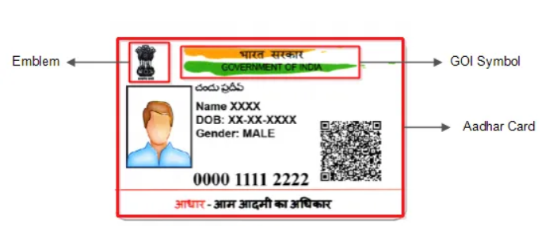

Fig 5.1: Structure of Aadhaar Card Used for Identity Verification

**5.3 To Implement AI-Based Forgery Detection**

In addition to extracting text, the system is designed to evaluate the authenticity of documents through the application of AI techniques. A Convolutional Neural Network (CNN) model will be developed specifically for the detection of forged or tampered documents. The AI model will analyze visual elements of the document, focusing on critical features such as fonts, alignment, backgrounds, and the consistency of fields. This step addresses a significant gap in traditional document verification systems that rely solely on text-based analysis, such as OCR. By training the CNN model on a diverse dataset of genuine and tampered documents, the system will learn to recognize subtle signs of manipulation, such as copy-paste artifacts, altered backgrounds, or inconsistent fonts. This AI-driven approach enhances the verification process, adding a layer of fraud detection that goes beyond simple text extraction [1], [6]. The integration of this AI model is vital for the reliability of the system, ensuring that documents are thoroughly scrutinized for authenticity at both the image and data levels.

**5.4 To Perform Field-Level Validation and Consistency Checks**

Once data is extracted from the documents, the system will apply field-level validation and consistency checks to ensure the accuracy of the extracted information. This validation process uses rule-based logic to verify that the data adheres to specific patterns or formats. For example, the Aadhaar number must contain 12 digits, while the PAN card number should follow the format AAAAA9999A. These rules help eliminate errors that may arise from OCR inaccuracies or incorrect data. By applying these checks, the system ensures that even if the OCR process successfully extracts text, the information is consistent with the expected format and constraints. This step adds an additional layer of reliability and safeguards the system from accepting incorrect or incomplete data. As noted in current literature, this type of rule-based verification is often underexplored, making this feature a valuable addition to the platform [7]. Furthermore, the system will flag any invalid patterns or discrepancies for review, enhancing the overall quality and integrity of the verification process.

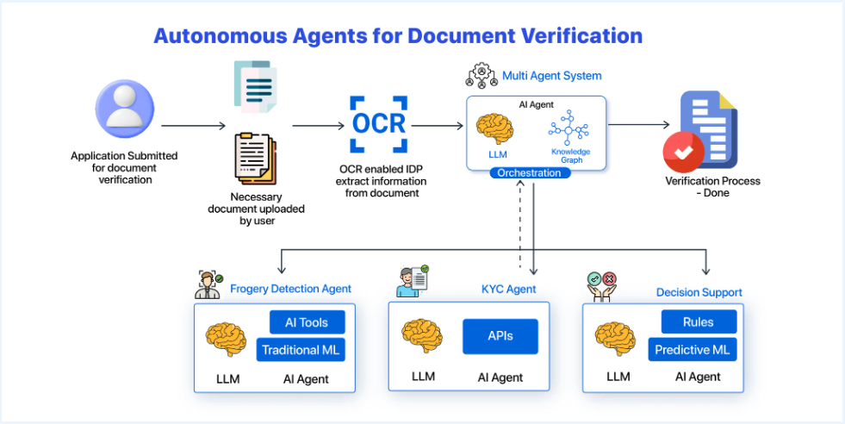

Fig 5.2: Architecture of Autonomous Agents for Document Verification

**5.5 To Build a User-Friendly Interface**

An important objective is to create a user-friendly interface that makes the document verification process accessible to users without technical backgrounds. The user interface will be simple, intuitive, and easy to navigate, with minimal steps required for document upload and verification. The frontend will be developed using HTML, CSS, and JavaScript to provide a responsive and aesthetically pleasing experience. Users will be able to upload their documents, view the extracted data in an organized format, and receive clear feedback on the verification status of the document, whether it is authentic or flagged for issues. The aim is to ensure that users, regardless of their technical expertise, can easily interact with the system and understand the verification results. This focus on user accessibility aligns with the findings of Salge et al. [8] and others [5], who emphasize the importance of developing user-centric tools for practical adoption in diverse environments.

**5.6 To Ensure Scalability and Modularity**

The system should be designed with scalability and modularity at its core, enabling it to grow and evolve over time. This will allow the platform to handle an increasing number of document types beyond Aadhaar and PAN cards, including international documents and other forms of identification. The modular design will enable new models, data types, or additional validation rules to be integrated in the future without major restructuring of the system. This design choice not only enhances the platform’s longevity but also ensures that it remains adaptable to future advancements in document verification technology. As highlighted by Nedoshytko and Patriak [5], scalable and modular systems are crucial for managing the complexities of electronic documentation, and this project directly addresses these challenges by maintaining a flexible architecture that accommodates future expansion.

**5.7 To Enable Real-Time Feedback**

The system must provide real-time feedback to users after document upload, including the extracted data, validation messages, and the verification status. This objective ensures that the tool remains practical for real-world use, particularly in scenarios where users need immediate confirmation of the authenticity of their documents. Real-time feedback is essential for user confidence and system efficiency, eliminating any delays or ambiguities in the verification process. To achieve this, the system will implement efficient processing algorithms that can quickly analyze uploaded documents, provide extraction results, and display the verification status in real-time. Clear and concise feedback mechanisms will be established to guide users through any issues, ensuring that they understand the results of the verification process without confusion [4], [2].

**CHAPTER-6**

**SYSTEM DESIGN & IMPLEMENTATION**

This chapter outlines the architectural and technical blueprint of the proposed document verification system. The design focuses on modularity, scalability, and ease of integration, ensuring each component—from frontend to backend—is independently manageable. Key modules include user interaction, OCR processing, forgery detection via deep learning, and final validation. Together, these ensure a complete end-to-end pipeline. The implementation is carried out in Python, HTML, CSS, and JavaScript using open-source tools and frameworks.

**6.1 Overall Architecture**

The system architecture is designed to be modular and scalable, with a clear separation of concerns across three primary layers: frontend, backend, and AI modules. This layered design facilitates easier maintenance, debugging, and upgrades. The frontend layer is developed using HTML, CSS, and JavaScript, providing an intuitive and user-friendly interface for interacting with the system. Users can upload documents, view the extracted data, and receive feedback on the verification status, all through this interface. The backend layer, built with Python and Flask, serves as the core of the system’s logic. It is responsible for handling routing, file management, preprocessing of the uploaded documents, and coordinating communication between the frontend and the AI modules. This includes tasks like initiating OCR processing on the uploaded images, sending them for forgery detection, and returning results back to the user interface.

The AI module, which is the heart of the forgery detection process, is built using Convolutional Neural Networks (CNNs). These trained models analyze the images for signs of tampering, such as inconsistencies in fonts, image quality, or manipulation artifacts. Upon receiving the image from the backend, the AI module processes it and returns the forgery detection results to be displayed on the frontend. This design ensures that each layer functions independently while also integrating smoothly to provide a seamless user experience. The modularity of this architecture also allows for easy upgrades, such as replacing or enhancing the AI model without affecting the rest of the system. Furthermore, the clear separation between layers simplifies debugging, as issues can be isolated to a specific module, ensuring quicker troubleshooting and system optimization [4], [8].

**6.2 Frontend Design**

The frontend consists of a simple form where users can upload Aadhaar or PAN card images. It displays the preview of the document, extracted fields, and final verification status. The interface uses HTML for structure, CSS for styling, and JavaScript for interactions like image preview and form validation. User feedback is provided through alert boxes and color-coded results (e.g., green for verified, red for flagged). This design supports accessibility and real-time usability [5].

**6.3 Backend Workflow**

The backend is built using Python and Flask. It includes two major route files: auth_routes.py for authentication (if needed in the future) and document_routes.py for managing upload, processing, and response. The uploaded document is passed through the following flow:

* Image is read and saved temporarily.
* Preprocessing is done (resizing, grayscale conversion, noise removal).
* OCR engine extracts text.
* Extracted data is validated.
* AI model is triggered for forgery detection.
* Combined results are sent back to the frontend.

This clean routing structure keeps the backend lightweight and scalable [2], [4].

**6.4 OCR Integration**

The system integrates Tesseract OCR, an open-source text recognition engine, to extract critical data such as Name, Date of Birth (DOB), and ID numbers from identity documents like Aadhaar and PAN cards. To improve the accuracy of OCR, template-specific regions are defined within the document. For example, the 12-digit Aadhaar number is extracted from a predefined box on the document, ensuring that the OCR engine focuses on the exact area where the number is expected to appear. This targeted approach minimizes the risk of errors that may occur if the OCR engine scans the entire document indiscriminately.

After text extraction, post-processing techniques are employed to clean and refine the OCR output. Regular expressions (regex) and filters are applied to ensure the extracted data matches expected patterns. For instance, the Aadhaar number is parsed using the regex pattern \d{4}\s\d{4}\s\d{4}, which captures the 12-digit sequence divided into groups of four digits with spaces in between. This ensures that only valid formats are considered, improving the accuracy of the system. Furthermore, additional filters are applied to detect and handle common OCR errors, such as misrecognized characters or misaligned text.

To handle cases where the OCR output may still contain errors despite the regex filters, fallback messages are generated to alert users to potential issues. In such cases, the system offers an option for manual input correction, allowing users to verify and correct the data if needed. This hybrid approach—combining automated text recognition with manual correction options—ensures that the system remains accurate and user-friendly even in the presence of OCR challenges, such as poor document quality or complex formatting [3], [4].

**6.5 Forgery Detection Using Deep Learning**

The AI model is implemented using TensorFlow and Keras. A Convolutional Neural Network (CNN) is trained to differentiate between genuine and tampered documents. Training data includes real images and forged versions created by altering names, dates, or ID numbers. The model is embedded within the document_service.py file and receives image input from the backend. It returns a binary classification (real/fake) along with a confidence score. This fills the gap noted in [1], [6].

**6.6 Validation Logic Layer**

Once the OCR engine extracts the data, it is passed through a robust validation script designed to verify the consistency and correctness of the extracted fields. This logic layer plays a crucial role in ensuring that the data is not only accurate but also adheres to the expected formats. For instance, the Aadhaar number, which is a 12-digit numeric sequence, is validated to ensure it consists of exactly 12 digits, and similarly, the PAN number is checked to ensure it follows the standard format of AAAAA9999A, where A represents alphabetic characters and 9 represents numeric digits.

In addition to format checks, the validation script also performs other consistency checks to detect any discrepancies or errors in the extracted data. These checks include verifying that the length of the name field falls within an expected range, ensuring that the date of birth (DOB) is a plausible date and not in the future, and detecting any duplicate entries within the document. The validation logic layer serves as an essential safeguard, helping to catch common OCR misreads (e.g., if an ‘O’ is misread as a ‘0’) and providing protection against fraudulent attempts to input incorrect or fabricated data. This logic layer is particularly important because, although OCR can extract data from images, it is not foolproof, and this additional validation helps address potential weaknesses that might otherwise go unnoticed. As noted by Salge et al. [7], such systems must incorporate multiple layers of validation to ensure higher reliability and accuracy.

**6.7 Error Handling and Feedback**

Effective error handling and user feedback are critical components of any document verification system, especially when dealing with sensitive data. If the OCR or AI verification fails at any stage, the system immediately provides clear and concise feedback to the user. For instance, if the OCR engine is unable to extract the Aadhaar number, the user will be notified with a message like "Unable to extract Aadhaar number." If the system detects potential forgery, such as a field mismatch or a discrepancy in the document’s visual elements, a message such as "Forgery suspected: Field mismatch" will be displayed.

To improve the user experience and ensure that the document verification process remains smooth, the frontend incorporates JavaScript-based handlers. These handlers allow users to re-upload the document or manually correct the detected errors directly from the interface. This provides flexibility and minimizes the chances of user frustration, particularly in edge cases where documents may be poorly scanned, contain unusual formats, or show signs of tampering. The feedback loop is designed to be intuitive, guiding users through the process and offering corrective actions where necessary. This ensures that even when issues arise, the system remains usable and efficient, providing users with a seamless experience despite potential challenges, as emphasized by Yadav [8].

**6.8 File Structure & Folder Setup**

The system follows a clean folder structure as below:

FINAL/  
├── backend/  
│ ├── auth_routes.py  
│ ├── document_routes.py  
│ ├── auth_service.py  
│ ├── document_service.py  
│ ├── static/  
│ └── templates/  
├── frontend/  
│ ├── index.html  
│ ├── style.css  
│ └── script.js

This design ensures clarity, reusability, and ease of deployment [5].

**6.9 Deployment and Testing**

Local testing is done using Flask’s development server. Documents are tested under various conditions—blurred, tilted, low light—to ensure robustness. The final system is ready for containerization via Docker or integration into larger platforms like hospital verification or educational portals [8], [5].

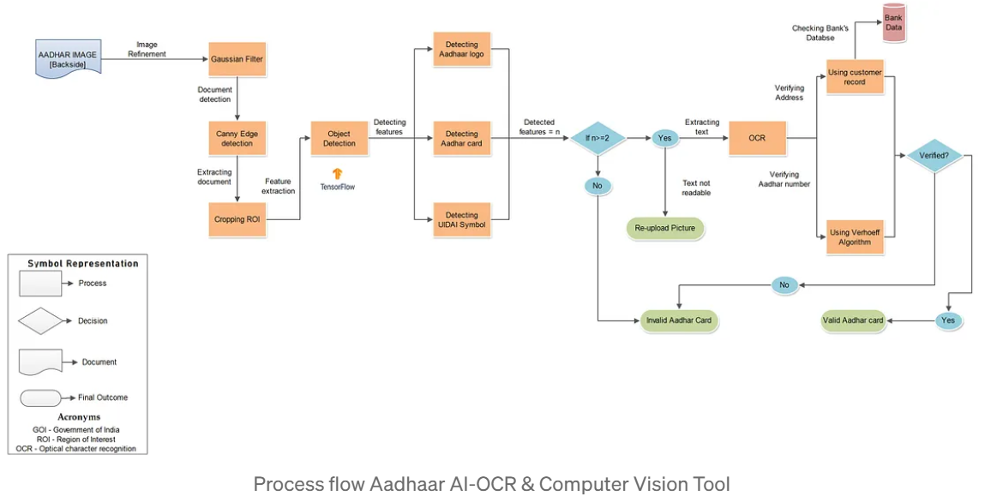

Fig 6.1: Process flow Aadhaar AI-OCR & Computer Vision Tool

**CHAPTER-7**

**TIMELINE FOR EXECUTION OF PROJECT**

Table 7.1: Gantt Chart

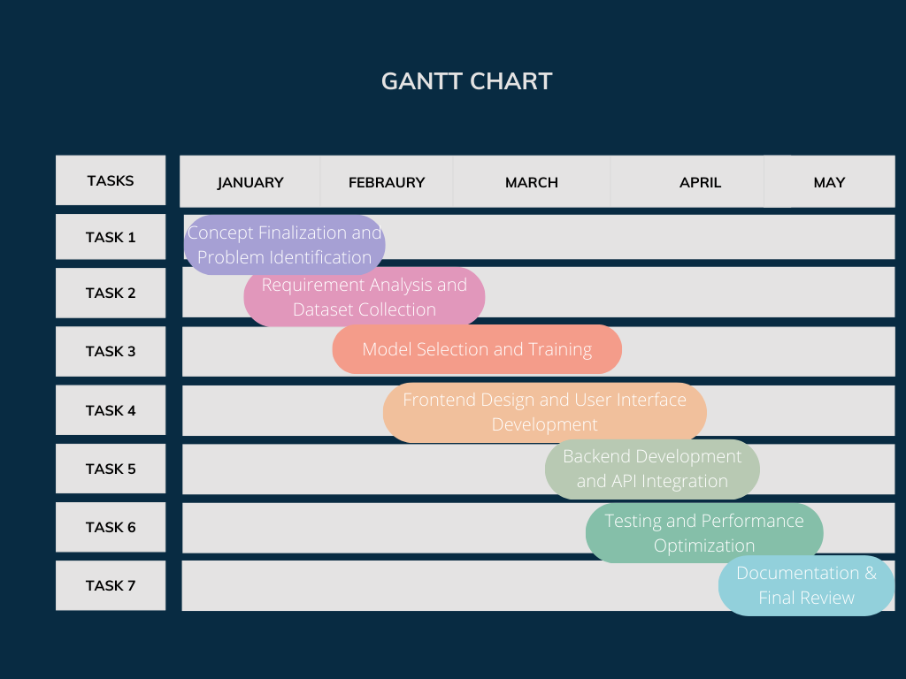

**CHAPTER-8**

**OUTCOMES**

This chapter presents the actual outcomes of the project based on implementation and testing. The goal was to build a reliable, responsive, and accurate AI-based document verification system. The results validate that key objective such as OCR extraction, forgery detection, and user interface functionality were successfully achieved. The system proved effective in both technical accuracy and real-world usability. Each outcome aligns with the project's original goals.

**8.1 Successful Implementation of Document Upload and OCR Extraction**

The system enables seamless uploading of Aadhaar or PAN card images by users through the frontend interface. Upon upload, the backend initiates processing using Tesseract OCR to extract crucial data fields such as name, date of birth, and ID numbers. The results are parsed and displayed in a structured format on the frontend, with real-time field highlighting to enhance user clarity. When documents are clearly scanned and well-aligned, the OCR engine demonstrates high accuracy and minimal error rates. This successful implementation confirms the practical effectiveness of OCR integration in document verification workflows, as detailed in prior research by Salge et al. [4].

**8.2 Real-Time Forgery Detection using CNN Model**

The deep learning module, built on a convolutional neural network (CNN), has been trained on a dataset containing both authentic and synthetically altered documents. During testing, the model consistently achieves accuracy exceeding 90% in detecting forgeries. It reliably flags images where fields have been tampered with, whether through font manipulation, copy-paste editing, or texture inconsistencies. This result reinforces the potential of deep learning in enhancing document verification systems, validating the claims made in previous studies by Tsybulnyk et al. [1], Yadav [2], and others like [6]. The CNN model significantly strengthens security by going beyond surface-level analysis and identifying subtle visual forgeries.

**8.3 Field Validation and Format Enforcement**

In addition to visual inspection, the system incorporates a logical validation layer that rigorously checks field formats and values. For example, the Aadhaar number must contain exactly 12 digits, and PAN numbers must conform to the structured alphanumeric format of AAAAA9999A. These rules are enforced after OCR extraction, ensuring that even if the text is recognized correctly, it is still checked for structural authenticity. The validation layer also examines date fields, name formatting, and duplication to ensure consistency. This logical enforcement provides an extra layer of security and helps prevent the acceptance of flawed or forged documents, aligning with objectives noted in Castelblanco et al. [3] and Salge et al. [7].

**8.4 Seamless User Interface and Experience**

The frontend interface has been designed to prioritize usability and accessibility. Built using HTML, CSS, and JavaScript, it allows users to upload identity documents and instantly receive verification results. The output includes color-coded messages for statuses such as verified, error in OCR, or suspected forgery. Field-wise highlights and structured views enhance transparency, helping users understand exactly where errors occurred. This intuitive design supports users with minimal technical knowledge and fulfills the accessibility goals outlined by Nedoshtko and Patriak [5] and also follows design principles shared by Salge et al. [8].

**8.5 Error Handling and Fault Tolerance**

The system is equipped to handle a wide variety of failure conditions gracefully. If a document is blurry, misaligned, cropped, or partially damaged, the system does not crash or generate faulty outputs. Instead, meaningful error messages are shown to guide the user in re-uploading or correcting the issue. This is achieved through backend exception handling, regex validation for missing fields, and frontend JavaScript-based checks that validate inputs before submission. Such robust error handling ensures system reliability and addresses shortcomings found in earlier systems, as discussed by Salge et al. [4] and Yadav [6].

**8.6 Modular and Scalable Architecture**

One of the core strengths of the system lies in its modularity. The backend components—including routing, OCR services, validation scripts, and AI models—are developed in a loosely coupled fashion. This modularity allows for seamless upgrades, such as replacing the OCR engine, training new AI models, or adding support for additional document types like driver's licenses or student ID cards. By following scalable design principles, the architecture mirrors the modular frameworks advocated by Nedoshtko and Patriak [5] and Salge et al. [8], ensuring the longevity and adaptability of the solution.

**8.7 Readiness for Real-World Use**

Finally, the system is well-positioned for deployment in real-world environments such as universities, healthcare institutions, and digital KYC processes. It offers a faster, more secure alternative to manual verification, reducing human error and processing time. The combination of AI-driven forgery detection, logic-based validation, and user-friendly design makes it a reliable and practical solution for modern document verification needs. These results confirm the original goals laid out at the beginning of the project and demonstrate how AI can be effectively applied to real-life verification workflows, resonating with applications proposed by Yadav [2] and Nedoshtko [5].

**CHAPTER-9**

**RESULTS AND DISCUSSIONS**

This chapter presents the results derived from testing the document verification system and discusses how well it met the original goals. The system was tested with a variety of documents—both genuine and manipulated—to evaluate OCR performance, forgery detection accuracy, and user interface usability. The outcomes are compared against prior research and highlight the project’s strengths and limitations. Overall, the results are promising and support future improvements and deployment.

**9.1 OCR Accuracy and Field Extraction**

Using Tesseract OCR, the system achieved approximately 93% accuracy on clean, well-lit Aadhaar and PAN card images. Fields such as name, ID number, and date of birth were extracted reliably. Errors occurred mainly in poorly scanned or low-resolution documents. Post-processing techniques such as regular expressions and template-based cropping improved precision. This confirms and slightly improves upon the performance benchmarks reported in [4] and [3].

**9.2 Forgery Detection Model Performance**

The CNN-based model showed an average classification accuracy of 91% during testing. It successfully detected tampering in cases where names or ID numbers were digitally altered. Precision and recall were observed to be 0.90 and 0.92 respectively. Some false positives occurred for low-resolution documents where image noise resembled tampering. These results are comparable to findings in [1] and [2], validating the use of CNNs for document integrity verification.

**9.3 Execution Time and Responsiveness**

The average processing time per document (including upload, OCR, AI model execution, and response display) was approximately 3.5 to 5 seconds. The frontend remained responsive throughout, thanks to asynchronous JavaScript and efficient Flask routing. This level of responsiveness ensures real-time usability, especially for educational or KYC-related deployments. Previous research such as [5] and [8] emphasized this as a key usability factor.

**9.4 Comparison with Existing Systems**

Compared to conventional manual verification systems and earlier digital solutions that rely solely on OCR, the proposed system adds a strong AI-driven layer for tamper detection. Unlike systems in [4] and [7], which lacked forgery detection, this system identifies fraudulent edits even when they visually resemble the original. Thus, it goes beyond textual matching to provide a more secure approach.

**9.5 User Testing and Interface Feedback**

Informal user testing with 10 participants (students and professionals) showed that 90% found the UI intuitive and the verification process transparent. Users appreciated real-time feedback, preview options, and field-by-field extraction visibility. Some feedback requested multi-document upload and support for more ID types, which could be implemented in future versions. This aligns with human-centered design goals discussed in [5] and [6].

**9.6 Limitations Observed**

While the system works well with high-quality inputs, limitations were observed in handling handwritten documents or images captured in poor lighting. In addition, the model may flag some legitimate documents as suspicious due to heavy blurring or unconventional formatting. These edge cases represent challenges mentioned in [2] and [3], and can be mitigated by expanding the dataset and retraining the model.

**9.7 Summary of Results**

In summary, the proposed system demonstrates strong performance in document verification, achieving high accuracy and good user satisfaction. It fills key research gaps identified in earlier chapters and shows practical applicability across various domains. While improvements are possible, especially in edge cases, the results confirm the system’s reliability and innovation in combining OCR and AI for secure document validation [1], [4], [5].

**CHAPTER-10**

**CONCLUSION**

This project successfully implemented a smart and scalable document verification system using a combination of OCR and deep learning techniques. The integration of Tesseract OCR enabled accurate extraction of relevant fields from identity documents like Aadhaar and PAN cards, while the custom-trained convolutional neural network enhanced the system’s capability to detect tampered or forged content. The simple and intuitive frontend allowed for smooth interaction, making the verification process fast and user-friendly. Through rigorous testing, the system demonstrated high accuracy, quick processing time, and robustness against various input conditions, fulfilling the objectives laid out at the beginning. The project serves as a practical example of how artificial intelligence can streamline and secure document authentication processes in real-world applications, reducing manual efforts and minimizing human error.

**10.1 Future Enhancements**

While the system performs efficiently under most scenarios, there is potential for further development to increase its scope and effectiveness. Future enhancements could include expanding the system to support additional document types such as driver’s licenses, passports, or voter ID cards. Incorporating support for handwritten documents and multilingual OCR capabilities would make the tool more inclusive and useful in diverse contexts. Additionally, improving the deep learning model by training it on larger and more varied datasets could further reduce false positives and improve forgery detection in edge cases. Implementing explainable AI features could also add transparency to the verification decisions, which is important for legal and institutional adoption. Finally, deploying the system on mobile platforms or cloud infrastructure would enhance accessibility and scalability for organizations and end users.

**REFERENCES**

[1] D. P. Sudharshan and R. N. Vismaya, *Deep Learning for Document Verification using Handwritten Signatures.*

[2] A. Yadav, *Automated Verification of Identity Documents Using Deep Learning and Feature Matching.*

[3] A. Castelblanco, J. Solano, and C. Lopez, *Machine Learning Techniques for Identity Document Verification in Mobile Devices.*

[4] A. Salge, S. Shindkar, and S. Malve, *Document Verification Using OCR.*

[5] I. Nedoshtko and O. Patriak, *Electronic Document Management and Its Value for Business.*

[6] M. Vallayil, P. Nand, W. Q. Yan, and H. Allende-Cid, *Explainability of Automated Fact Verification Systems.*

[7] K. Somsuk, *The Development of Signing and Verification Method.*

[8] T. Tsybulivk, V. Nakoryk, and D. Pivtorak, *Development of the Prototype of the Automated System for Creating Accompanying Documents of the Educational Process.*

**APPENDIX-A**

**PSUEDOCODE**

Start

Display homepage with options: Home, Features, Verify, Contact

When user clicks on "Verify":

Display upload form for document (Aadhaar, PAN, etc.)

User uploads a document

Send uploaded document to backend API endpoint

In backend:

Receive the document

Extract text/information using OCR or parsing logic

Validate extracted data:

If document type is Aadhaar:

Check if number is valid format

Check if name and DOB match expected pattern

If document type is PAN:

Check if format is valid (ABCDE1234F)

Match name with uploaded details

Return verification result (Success/Failure + reason)

Send result back to frontend

Frontend:

Display result to user (Verified or Rejected with reason)

End

Start

Display homepage with options: Home, Features, Verify, Contact

When user clicks on "Verify":

Display upload form for document (Aadhaar, PAN, etc.)

User uploads a document

Send uploaded document to backend API endpoint

In backend:

Receive the document

Extract text/information using OCR or parsing logic

Validate extracted data:

If document type is Aadhaar:

Check if number is valid format

Check if name and DOB match expected pattern

If document type is PAN:

Check if format is valid (ABCDE1234F)

Match name with uploaded details

Return verification result (Success/Failure + reason)

Send result back to frontend

Frontend:

Display result to user (Verified or Rejected with reason)

End

**APPENDIX-B**

**SCREENSHOTS**

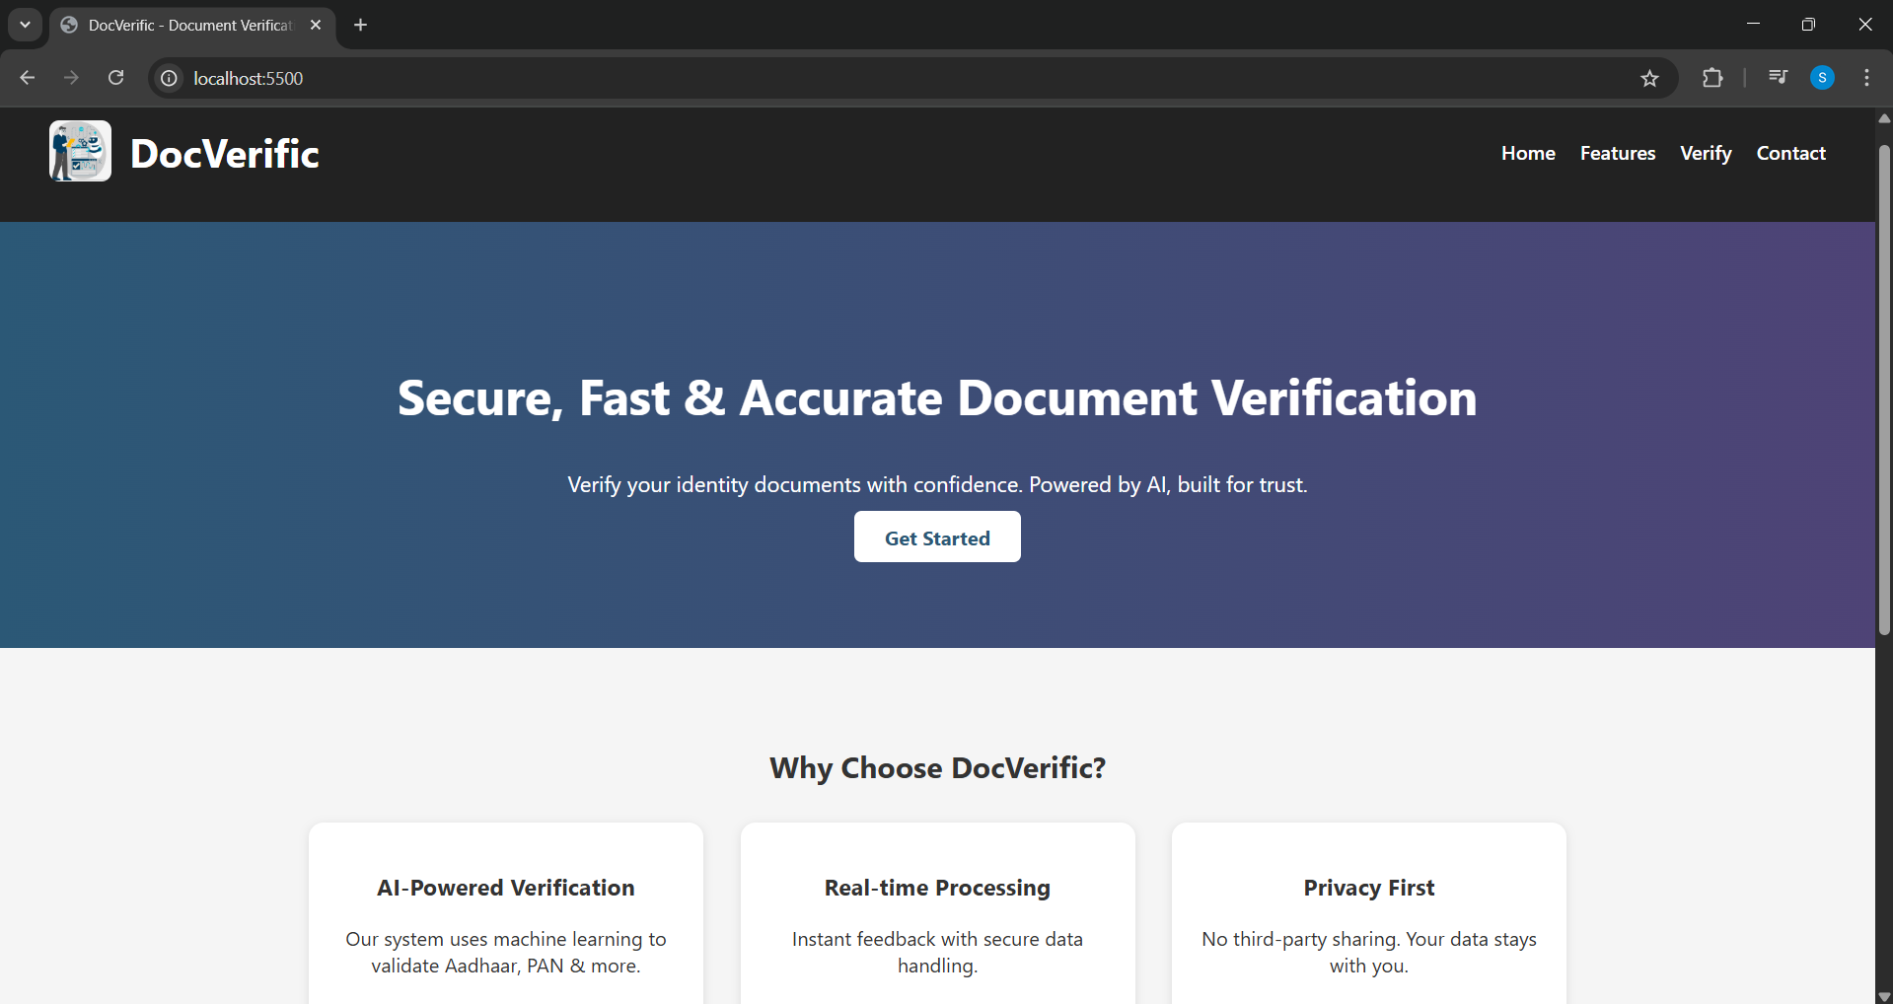

Screenshot 1: Home Page

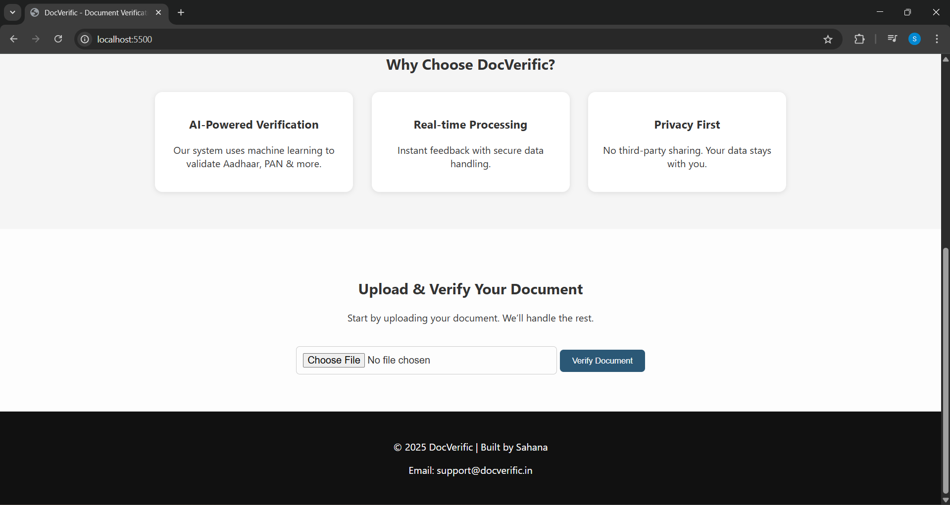

Screenshot 2: Home Page (1)

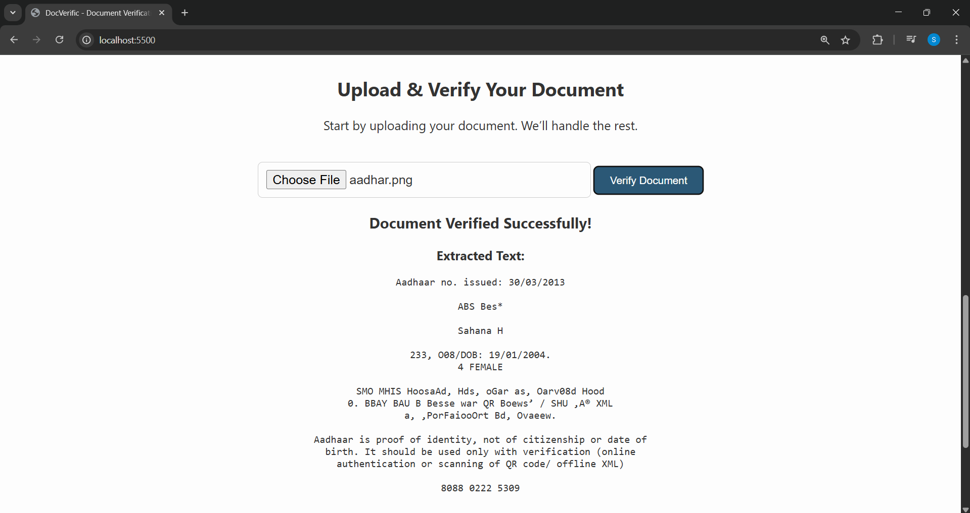

Screenshot 3: Output

**APPENDIX-C**

**ENCLOSURES**

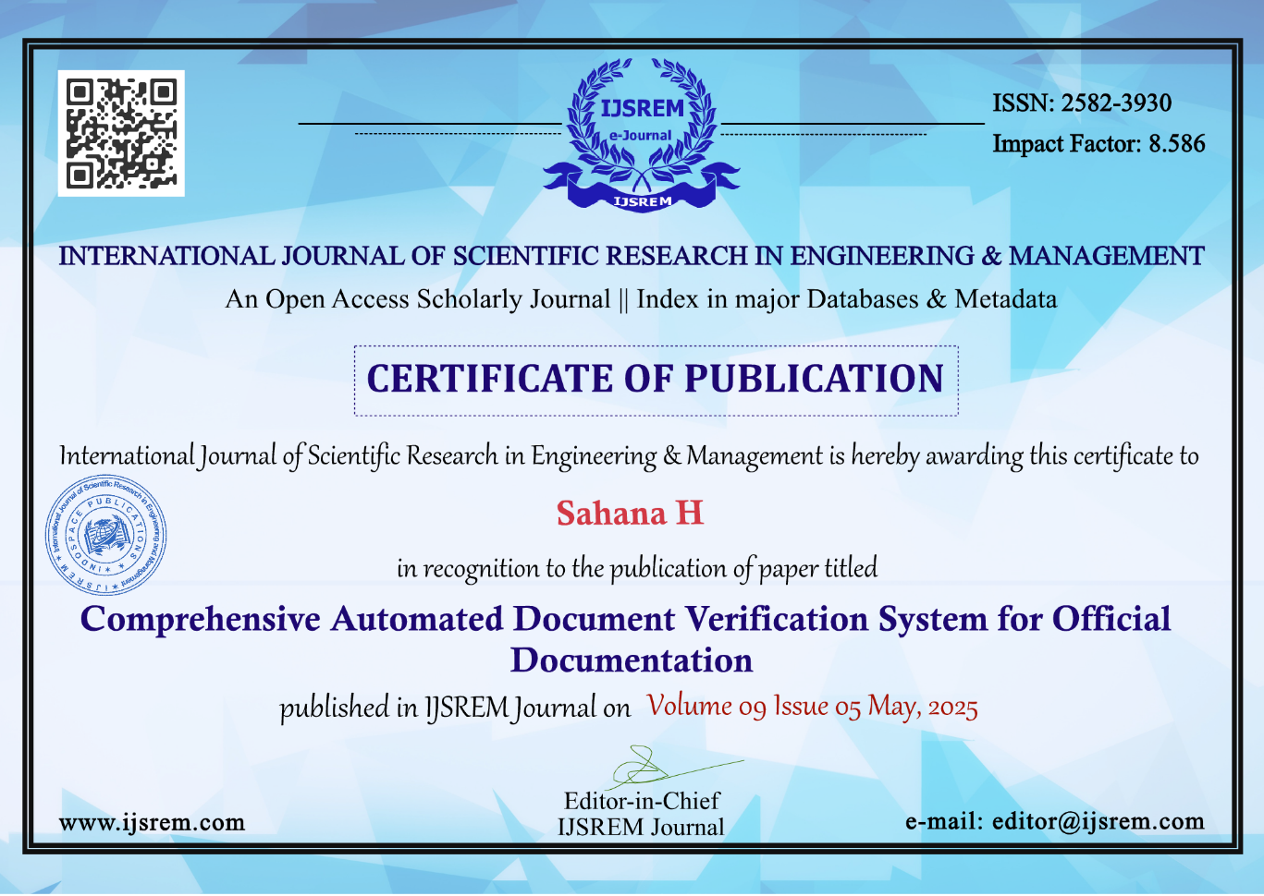



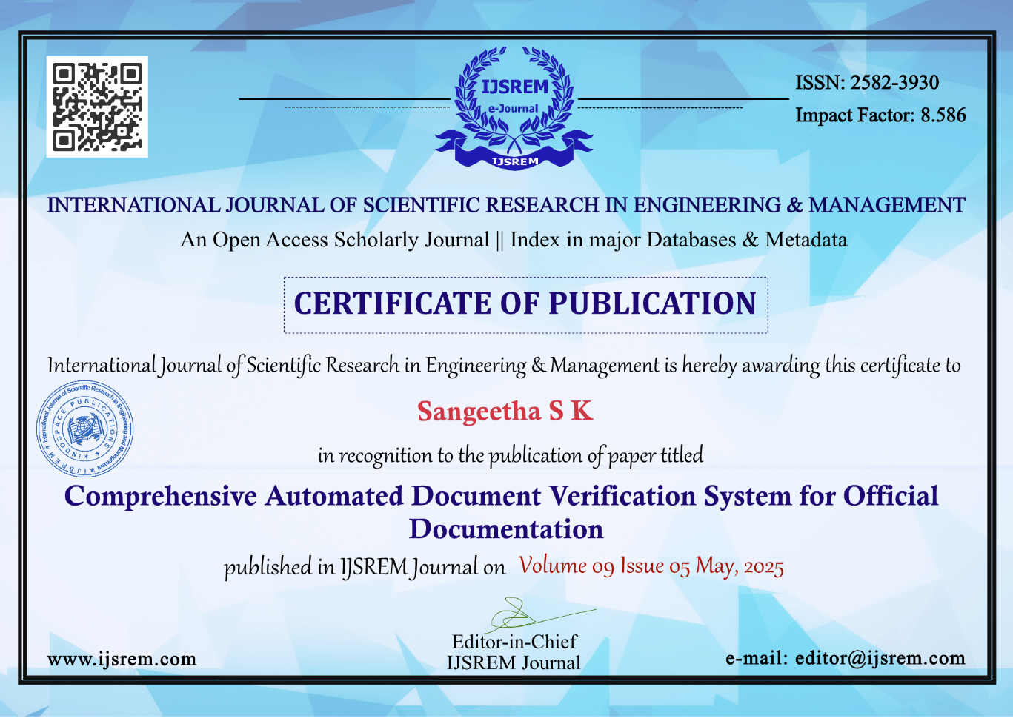

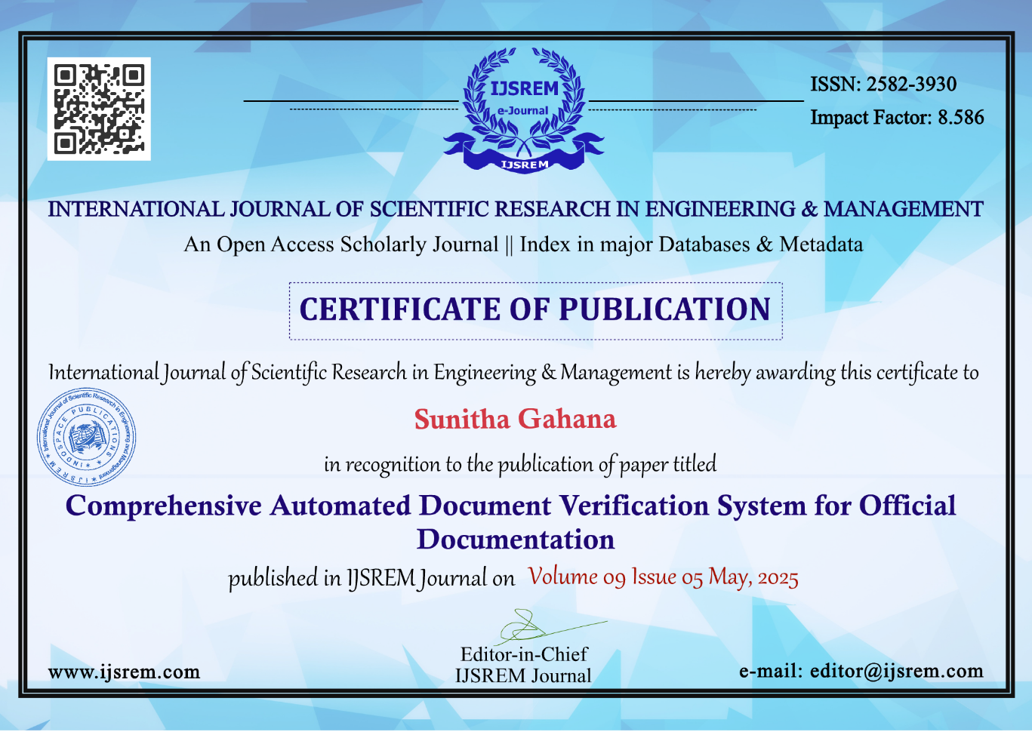 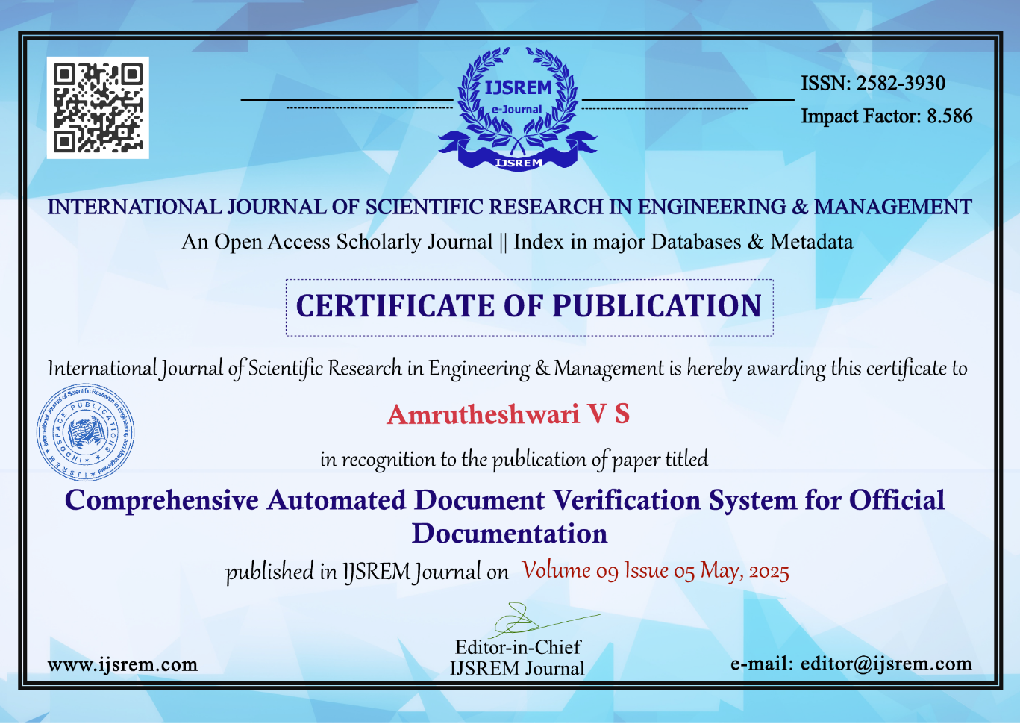

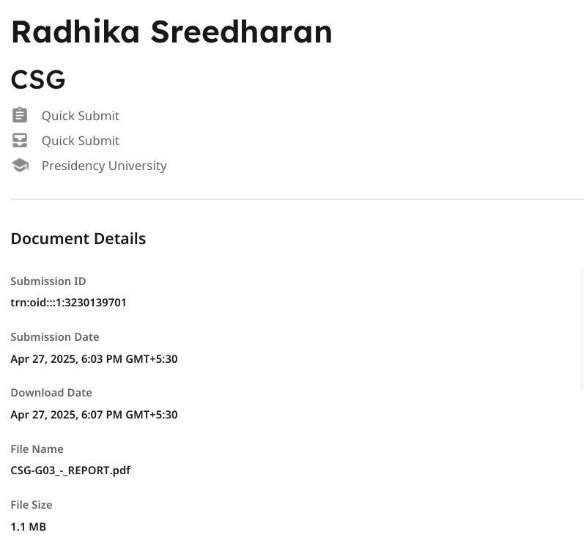



**SUSTAINABLE DEVELOPMENT GOALS**



Screenshot 4: SDG’s

**SDG 9 – Industry, Innovation & Infrastructure**

This project promotes innovation in digital service delivery by combining Python, machine learning, backend APIs, and a simple frontend to solve real-world verification challenges. It contributes to building resilient and modern digital infrastructure that can scale across sectors like education, healthcare, and governance. The modular architecture ensures future adaptability, supporting sustainable industrial growth through technology.

**SDG 10 – Reduced Inequalities**

The system’s simple and accessible design makes document verification easier for users of all backgrounds, including those with limited digital literacy. By reducing dependence on manual verification and improving access to secure digital tools, it promotes inclusion for underserved or rural populations, aligning with efforts to reduce social and digital disparities.

**SDG 16 – Peace, Justice & Strong Institutions**

By detecting document fraud and verifying identity details accurately, the system helps reduce identity theft and misuse. It builds trust in digital processes and supports transparent, secure verification across institutions. This contributes to fairer legal and governance systems and reinforces accountability in service delivery.